7.1.26 Editors - 3D View - Header - Curve & Surface - Edit mode - Segments menu
Edit Mode - Segments Menu 1
Subdivide 1
Last Operator Subdivide 1
Number of Cuts 1
Switch Direction 1

Edit Mode - Segments Menu

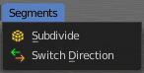
The Segments menu exists for Curve and Surface object types. They are both curve types, but of different kind.

The added objects in edit mode becomes part of the current object geometry.

Subdivide
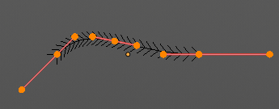
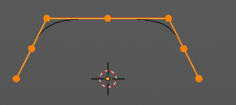
Subdivides the selected curve geometry, and adds more control points.


Last Operator Subdivide

Number of Cuts
Number of subdivision cuts.

Switch Direction
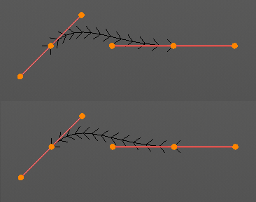
Just for Bezier Curve object type. Surface Nurbs curves doesn't have a direction. Switches the direction in which the curve is pointing.

